CODE BLOCKS

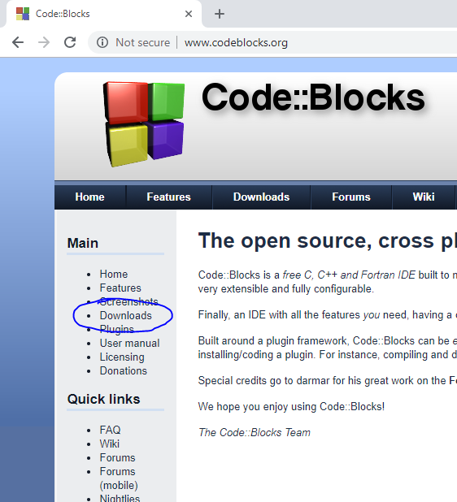

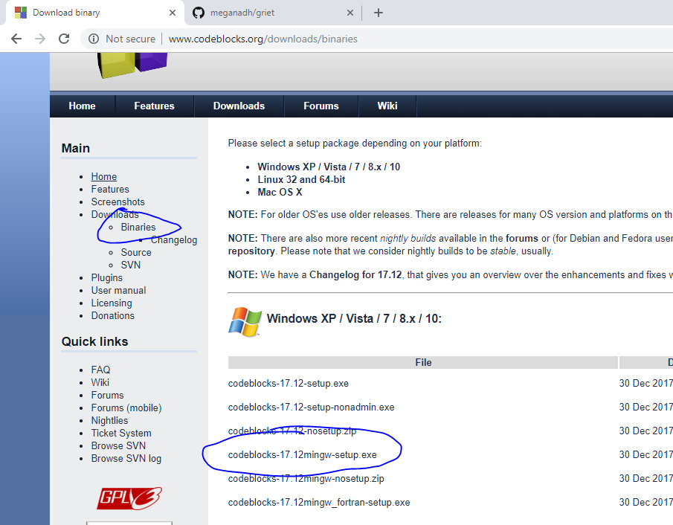

Stdio.h – standard input output header file

After typing code

Save the file 🡺 Compile 🡺 Run the code